World Ocean Day Quiz Programme : Report
The Department of Zoology, St. Stephen's College, Uzhavoor, organized an awareness quiz programme on 8 June 2026 in observance of World Ocean Day. The programme aimed to create awareness among students and staff about the importance of oceans, marine biodiversity, and the need for ocean conservation.
The quiz was conducted by the students of the Department of Zoology and witnessed active participation from students and faculty members of various departments. Questions covered topics such as marine ecosystems, ocean pollution, climate change, aquatic biodiversity, and sustainable use of marine resources.
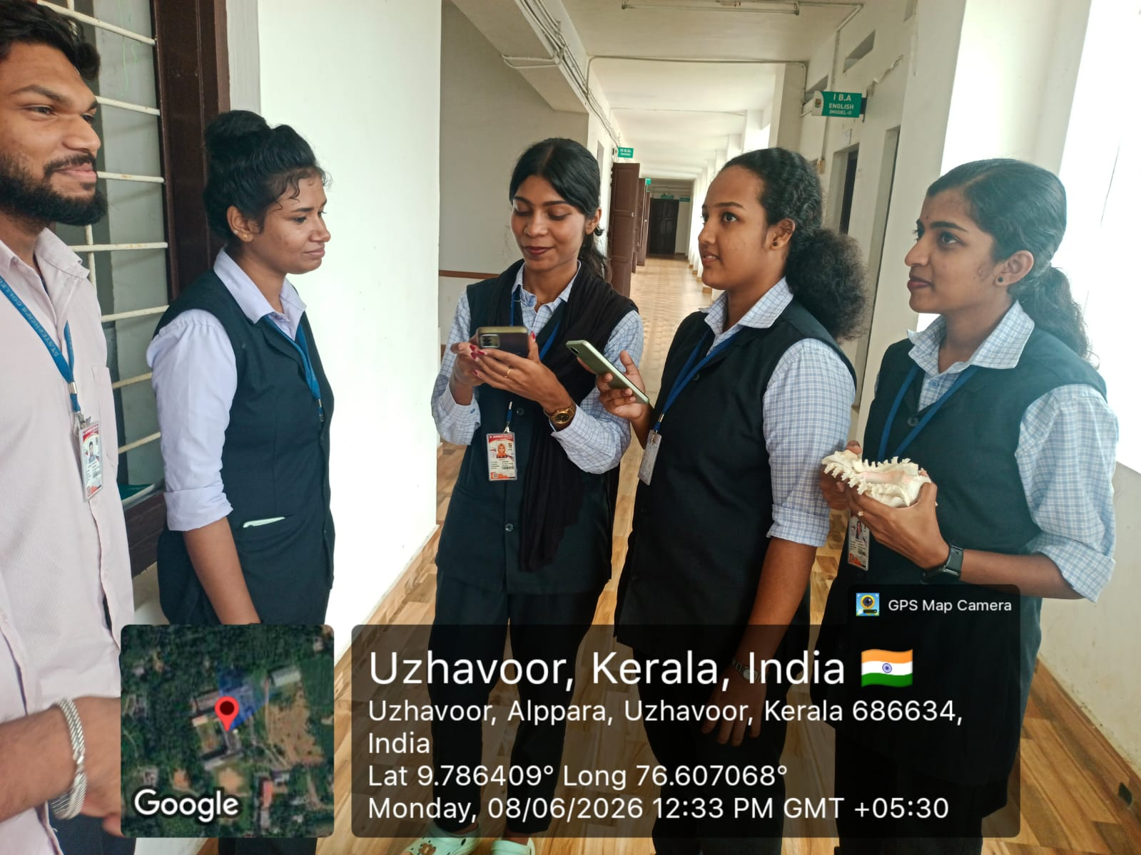
The programme served as an effective platform to enhance environmental awareness and promote responsible attitudes towards the conservation of ocean resources. Participants appreciated the initiative, and the event successfully conveyed the message of protecting oceans for future generations.
